**The Cycle of 4ths/5ths.**

The ‘Cycle of 4ths/5ths’ is a tool that can be used for a range of applications. It is basically a circle, with the full list of notes arranged in intervals of 4ths (clockwise) and 5ths (counter-clockwise).

The important things is that it contains all twelve notes in the musical alphabet.

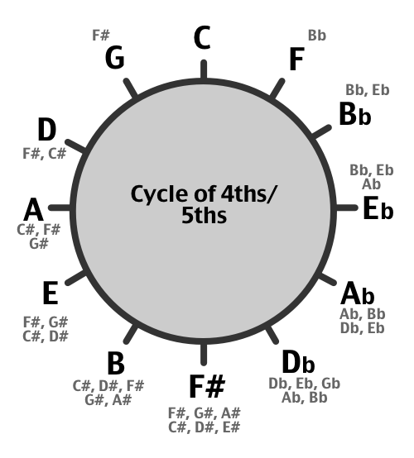

A better circle of fifth is

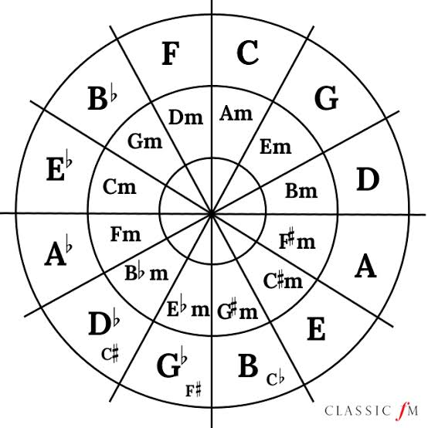

The circle of fifths, also called cycle of fourths.

An interval of a fifth is equal to 7 semitones or 7 frets on the guitar.

Counter-clockwise the circle moves in intervals of fourths which is equal to 5 semitones or 5 frets.

Recognizing Key Signatures

The cycle of fifths is an easy way of finding the key signature of a song

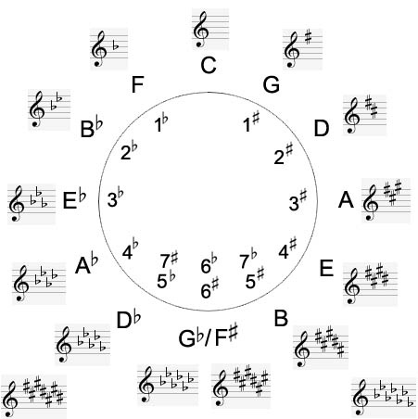

At the top the key of C has no sharps or flats.

Turn one step clockwise each time and the sharps add up. Next to C on the cycle you’ll find the key of G which has 1 sharp, then D has 2 sharps, A has 3 sharps and so on.

If you go anti-clockwise one step each time the flats up. To left of C you’ll find F which has 1 flat, then Bb has 2 flats, Eb has 3 flats, Ab has 4 flats and so on.

When you see a music score which makes no sense to you, but you see 3 sharps in the beginning of the note staff, you’ll know that the song is in the key of “A”.

Let’s take a look how many sharps, flats and which ones each key contains:

**C** contains 0 #’s  
**G**: 1 # = F#  
**D**: 2 # = F#, C#  
**A**: 3 # = F#, C#, G#  
**E**: 4 # = F#, C#, G#, D#  
B: 5 # = F#, C#, G#, D#, A#  
**F#**: 6 # = F#, C#, G#, D#, A#, E#  
**C#**: 7 # = F#, C#, G#, D#, A#, E#, B#

**F**: 1 b = Bb  
**Bb**: 2 b = Bb, Eb  
**Eb**: 3 b = Bb, Eb, Ab  
**Ab**: 4 b = Bb, Eb, Ab, Db  
**Db**: 5 b = Bb, Eb, Ab, Db, Gb  
**Gb**: 6 b = Bb, Eb, Ab, Db, Gb, Cb  
**Cb**: 7 b = Bb, Eb, Ab, Db, Gb, Cb, Fb